**Exploratory Analysis of Rain Fall Data in India for Agriculture**

|  |  |  |
| --- | --- | --- |
|  |  |  |

**TEAM LEADER : K. NITHYALAKSHMI**

**TEAM MEMBER : 1. A. MANI MEHALA**

**2. A.D. HIRETHICK**

**3. D. JAYANTHI**

**INDUSTRY MENTOR(S)**

**NAME : LALITHA GAYATHRI**

**FACULTY MENTOR(S)**

**NAME : Dr. J. HEMALATHA**

**TABLE OF CONTENT**

|  |  |  |
| --- | --- | --- |
| **1** | **INTRODUCTION**   * 1. Project Overview   2. Purpose |  |
| **2** | **LITERATURE SURVEY**  2.1 Existing Problem  2.2 Reference  2.3 Problem Statements Definition |  |
| **3** | **IDEATION & PROPOSED SOLUTIONS**  3.1 Empathy Map Canvas  3.2 Ideation & Brainstorming  3.3 Proposed Solution  3.4 Problem Solution Fit |  |
| **4** | **REQUIREMENTS ANALYSIS**  4.1 Functional Requirements  4.2 Non-Functional Requirements |  |
| **5** | **PROJECT DESIGN**  5.1 Data Flow Diagram  5.2 Solution & Technical Architecture  5.3 User Stories |  |
| **6** | **PROJECT PLANNING & SCHEDULING**  6.1 Sprint Planning & Estimating  6.2 Sprint Delivery Schedule  6.3 Reports From JIRA |  |
| **7** | **CODING & SOLUTIONING**  7.1 Feature 1  7.2 Feature 2  7.3 Database schema (if applicable) |  |
| **8** | **TESTING**  8.1 Test Cases  8.2 User Acceptance Testing |  |
| **9** | **RESULTS**  9.1 Performance Metrics |  |
| **10** | **ADVANTAGE & DISADVANTAGE** |  |
| **11** | **CONCLUSION** |  |
| **12** | **FUTURE SCOPE** |  |
| **13** | **APPENDIX** |  |

**FIGURES**

**1.INTRODUCTION :**

In Today’s era global warming is affecting all over the world which majorly effect on mankind and cause the expedite the change in climate. Due to this air and oceans are warming, sea level is rising and flooding and drought etc. One of the serious consequences due to this climate change is on Rainfall. Rainfall prediction now days is an arduous task which is taking into the consideration of most of the major world-wide authorities. Rainfall is a climatic factor that aﬀects several human activities on which they are depended on for ex. agricultural production, construction, power generation and tourism, among others. This make the rainfall serious concern and requirement of better rainfall prediction. Rainfall is a complex atmospheric process, and due to the climate changes, it become more difficult to predict it.

* 1. **Project Overview**

In our experimental study we use the rainfall data collected from the official website of Indian government. The data collected is comprises more than a decade of measurement of rainfall in all over India. As the world if moving toward to the issue of water and in India specific the rainfall prediction is most important thing. So, in this paper we try to optimize the result and to find the model which is well suitable for the rainfall prediction in India specific region only.

The estimation of rainfall is of great importance in terms of water resources management, human life and their environment. It can be met with the incorrect or incomplete estimation problems because rainfall estimation is affected from the geographical and regional changes and properties. This project contains different methods used for rainfall prediction and problems one might encounter while applying different approaches for rainfall forecasting. Due to nonlinear relationships in rainfall data and ability of learning from the past makes Artificial Neural Network a preferable approach from all available approaches.

* 1. **Purpose**

The purpose of the study is the prediction of the rainfall using historical monthly data based on artificial intelligence methodologies such as support vector machine and artificial neural network. The extraction procedures/algorithms will produce the output by classification of the data according to the categories using SVM and ANN. The similar data will be grouped for the accurate and precise information that will predict rainfall more correctly and with perfect figures. The accurate and exact predictions will help in developing the more appropriate strategies for agriculture and water reserves and will also be informed about the flood to implement precautionary measures. Amongst all weather happenings, rainfall plays the most imperative part in human life.

**2. LITERATURE SURVEY:**

|  |  |  |  |  |
| --- | --- | --- | --- | --- |
| **S.NO** | **TITLE** | **YEAR** | **AUTHOR** | **CONTENT** |
| **1.** | A Machine Learning Approach for Rainfall Estimation Integrating Heterogeneous Data Sources | **2020** | Massimo Guarascio,  Gianluigi Folino,  Francesco Chiaravalloti, Salvatore Gabriele, Antonio Procopio and Pietro Sabatino. | 1) Dense networks of sensors, named rain gauges (RGs), were typically used to obtain direct measurements of precipitation intensity in individual geographical points.  2) Machine learning-based methodology is proposed that exploits a classifier based on ensemble methods for rainfall estimation and is able to integrate information from different remote sensing measurements. |
| **2.** | A Time-series based Prediction Analysis of Rainfall Detection | **2020** | Lince Rachel Varghese,  K. Vanitha (Dept. of CS., DR.G.R.Damodaran College, Coimbatore, India) | 1) This paper analyzes and studies the rainfall data patterns of all the districts of Kerala.  2) A time series analysis was used to extract the trends in seasonal rainfall. Data mining, data analysis is used on meteorological data to find hidden patterns in the data. |
| **3.** | Machine Learning Techniques to Predict Daily Rainfall Amount | **2021** | Chalachew Muluken Liyew and Haileyesus Amsaya Melese | 1) Main objective of the project was to identify the relevant atmospheric features that cause rainfall and predict the intensity of daily rainfall using machine learning techniques.  2) The Pearson correlation technique was used to select relevant environmental variables which were used as an input for the machine learning model. |
| **4.** | Study on Rainfall Prediction of Yibin City Based on GRU and XGBoost | **2022** | Jian Rong Ban, Qi Gou and Ya Shi Li | 1) In this paper, GRU and XGBoost algorithms are used to predict the rainfall in Yibin City, Sichuan Province, and the different prediction results of the two methods are compared.  2) Experiments have found that the mean absolute error (MAE) of GRU and XGBoost models are 0.088 and 0.013 respectively; The mean square error (MSE) is 0.016 and 0.0003 respectively; The mean average absolute percentage error (MAPE) was 58.22 and 14.85 respectively. |
| **5.** | Applying the Deep Neural Network to Estimate Future Trend and Uncertainty of Rainfall under Climate Change | **2022** | Shiu-Shin Lin, Wei-Li Yeh, Kai-Yang Zhu, Yu-Dong Ho and WeiCheng Wu | 1) This study proposes a deep neural network (DNN) as a downscaling framework to compare original variables.  2) The nonlinear data features extracted by kernel principal component analysis (KPCA). |

**2.1 Existing Problem**

Over the previous decade, academic and commercialized databases have been extending at exceptional rates. Capture advanced perception from such databases is hard, expansive and time-consuming if done manually. It is hopeless when data exceeds

definite limits of size and complexity. For this reason, during the previous years the automated analysis and visualization of huge multi-dimensional datasets has been the center of attention on scientific research. The fundamental aim is to observe rules and relationships in the data, thereby gaining attain to invisible and potentially valuable knowledge. Artificial Neural Networks are a hopeful part of this broad field. Motivated by advances in biomedical research, they shape a class of algorithms that goal to reproduce the neural structures of the brain. The reason is that ANN (Artificial Neural Network) model is based on 'prediction' by smartly 'analyzing' the trend from an already existing voluminous historical set of data.

Apart from ANN, the other models are either mathematical or statistical. These models have been found to be very accurate in calculation, but not in prediction as they cannot adapt to the irregularly varying patterns of data which can neither be written in form of a function, nor deduced from a formula. These real-life situations have been found to be better interpreted by 'artificial neurons' which can learn from experience, i.e by back- propagation of errors in next guess and so on. This may lead to a compromise in accuracy but give us a better advantage in 'understanding the problem', duplicating it or deriving conclusions from it. Amongst all weather happenings, rainfall plays the most imperative part in human life. Human civilization to a great extent depends upon its frequency and amount to various scales. Several stochastic models have been attempted to forecast the occurrence of rainfall, to investigate its seasonal variability, to forecast yearly/monthly rainfall over some geographical area.

**3.2 Reference**

**3.3 Problem Statement Definition**

.India being a predominantly agriculture based country.

• Main achievement of the agriculture is dependent on rainfall. Due to global warming and many other climate issues the weather conditions are changing for time being. Irregular heavy rains not only cause crop damage but may result in disasters. Rainfall has been a major concern these days.

• Weather conditions have been changing for time being. Rainfall forecasting is important otherwise, it may lead to many disasters. Irregular heavy rainfall may lead to the destruction of crops, heavy floods that.

• Can cause harm to human life. To prevent this we need a model to analyse and predict the rainfall by using rainfall data that has been accumulated over years with the help of Machine Learning.

• Resources, crop productivity, and pre-planning of water structures. With the knowledge provided by this model we secure crops from several disasters that affects the agriculture. Exploratory analysis will concentrate in the following aspects: model inputs.

• Data visualization, model parameters and the pre-processing techniques. Methods will be compared on various evaluation metrics and the dependability to predict the rainfall by analysing the data. Different types of parameters will be utilized to improve the performance of the model. The goal is to obtain high accuracy in forecasting the rainfall.

**3. IDEATION & PROPOSED SOLUTION**

**3.1 Empathy Map Canvas**

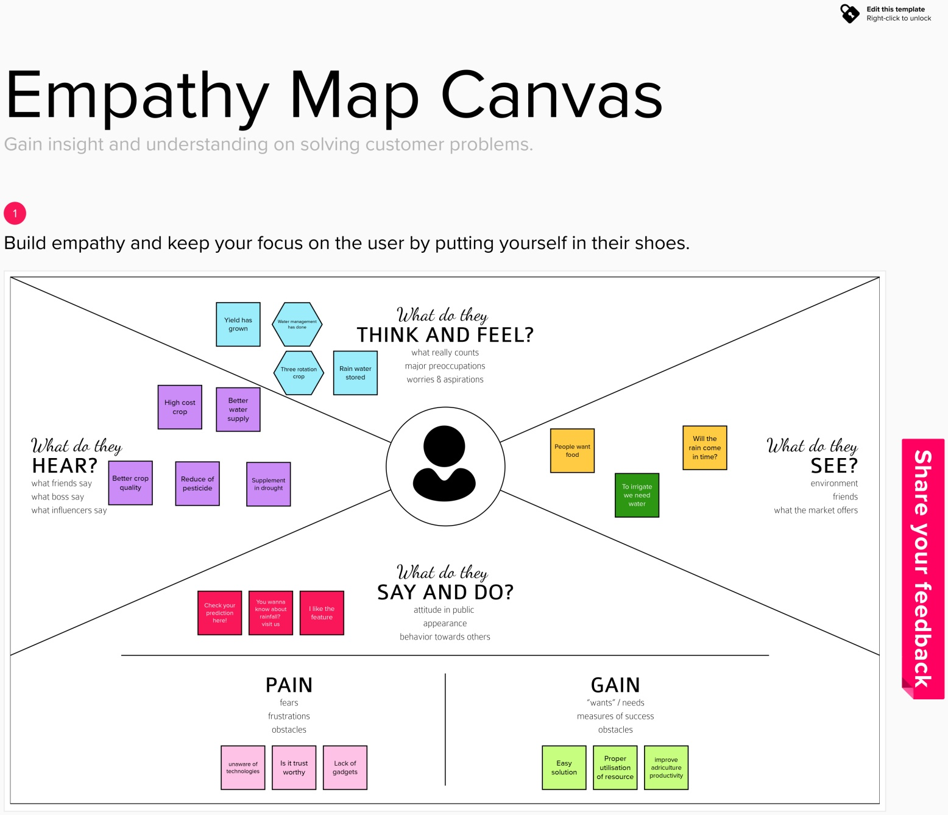



I like the feature

You wanna know about rainfall? visit us

Check your prediction here!

To irrigate we need water

**3.2 Ideation & Brainstorming**

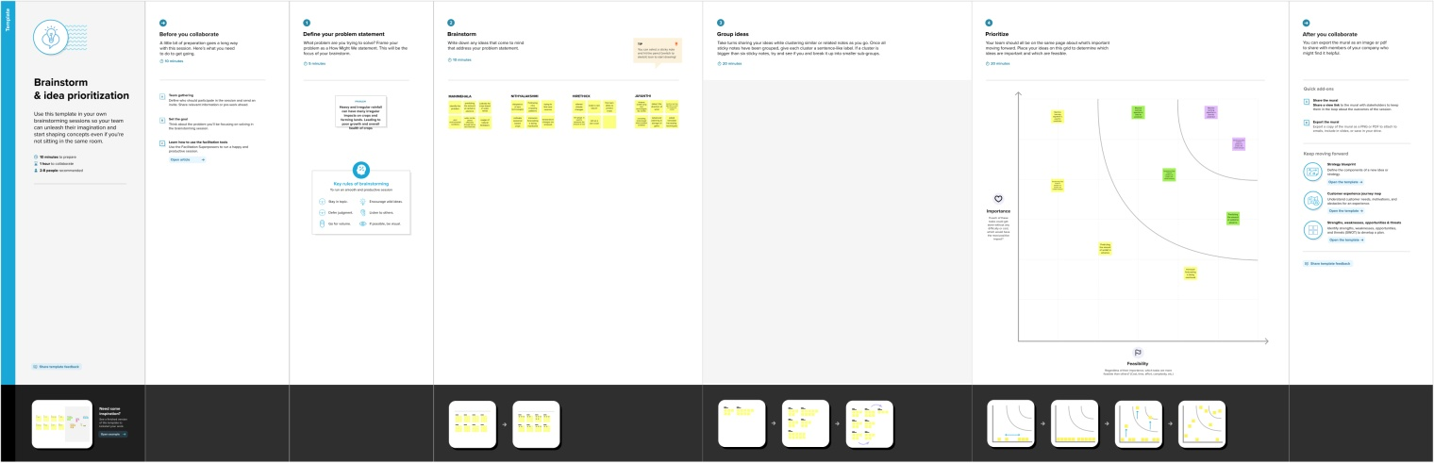

**3.3 Proposed Solution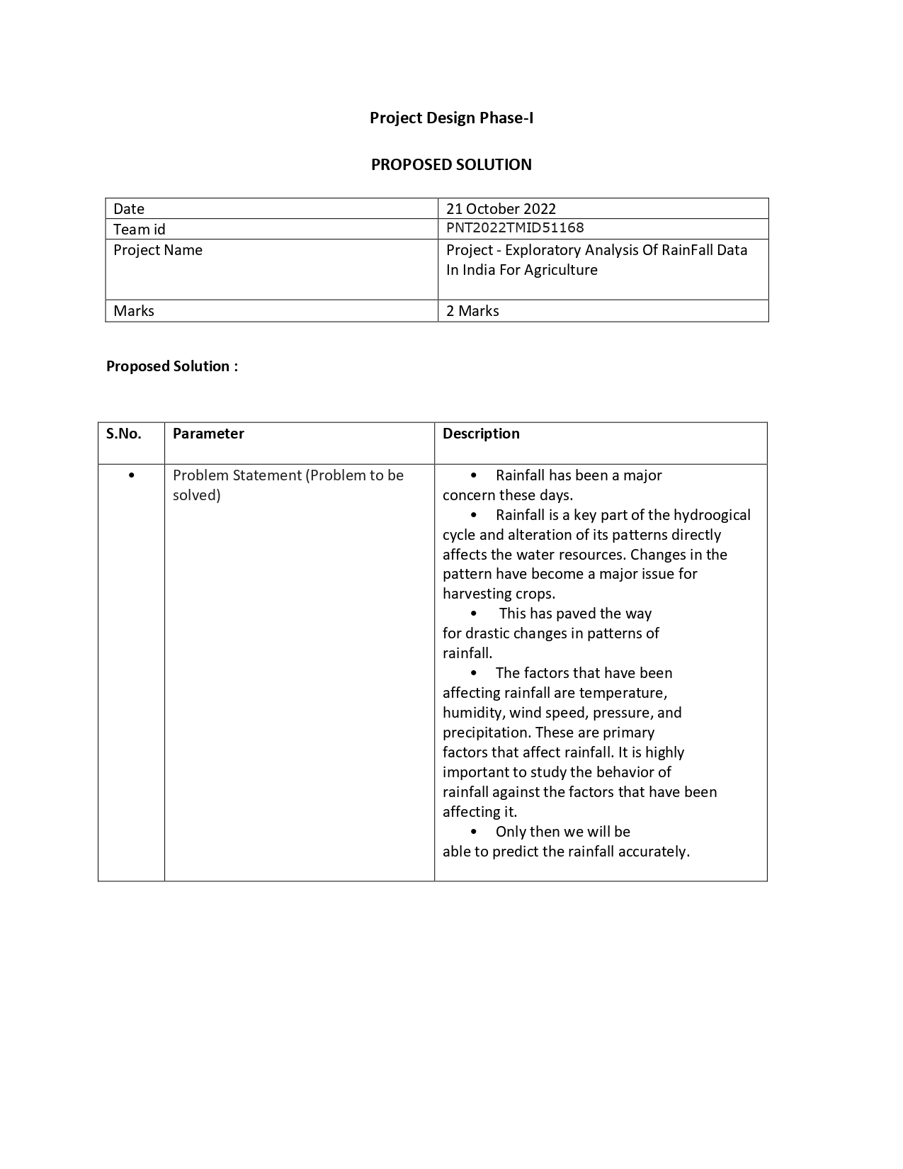4.Requirements Analysis**

**4.1 Functional Requirements**

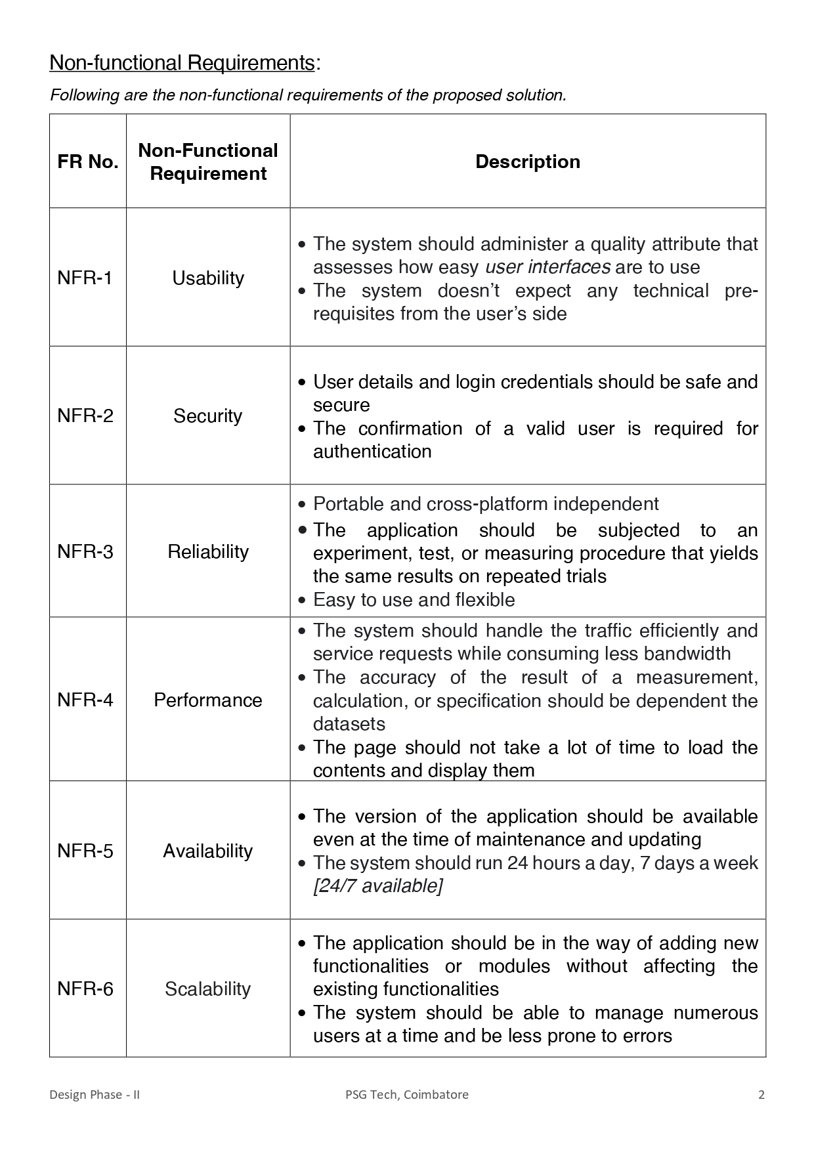

**5. Project Design**

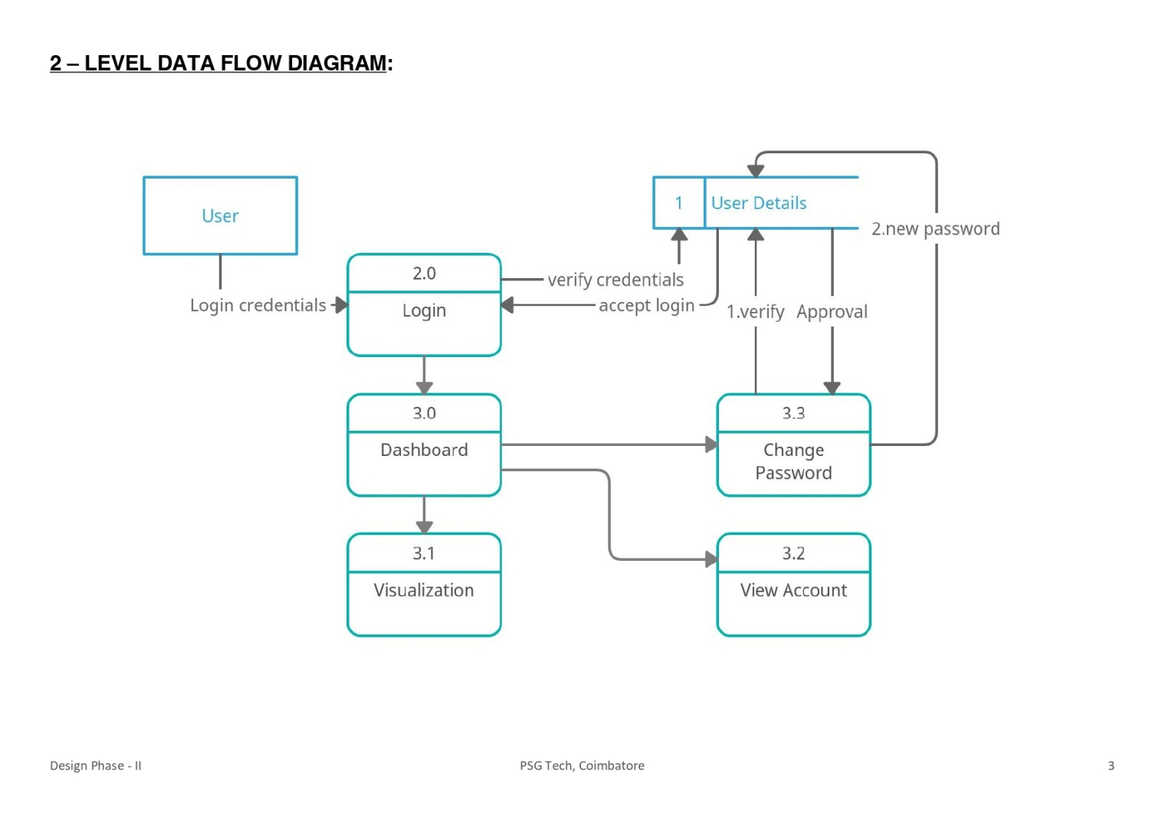

**6. Project Planning & Scheduling**

**6.1 Sprint Planning &Estimating**

**7.Coding & Solutioning**

|  |
| --- |
| <!Doctype > |

|  |
| --- |
|  |
|  | <Html> |
|  | <Head> |
|  | <Title> |
|  | EDA of Rainfall LOGIN!! |
|  | </Title> |
|  |  |
|  | <style type=text/css> |
|  | body |
|  | { |
|  | height: 125vh; |
|  | margin-top: 20px; |
|  | padding: 30px; |
|  | font-family: sans-serif; |
|  | } |
|  | </style> |
|  | </Head> |
|  | <Body> |
|  | <h1 style="color:rgb(216, 64, 64);"> |
|  | <center> EXPLORATORY ANALYSIS OF RAIN FALL DATA IN INDIA FOR AGRICULTURE</h1> </center> |
|  | <h2 style="color:white;"> |
|  | <center> <marquee> A Single Gentle Rain Makes The grass Many Shades Greener </marquee></h2> |
|  | <Title> |
|  | LOGIN PAGE |
|  | </Title> |
|  | <center><style type=text/css> |
|  | Body { |
|  | font-family: Calibri, Helvetica, sans-serif; |
|  | font-size: 190,90; |
|  | background-image: url("Capture.jpg.JPG"); |
|  | background-position: center; |
|  | background-repeat: no-repeat; |
|  | background-attachment: fixed; |
|  | background-size: cover; |
|  | } |
|  | <style> |
|  | Body { |
|  | font-family: Calibri, Helvetica, sans-serif; |
|  | background-color: white; |
|  | } |
|  | button { |
|  | background-color: red; |
|  | width: 100%; |
|  | color: rgb(255, 255, 255); |
|  | padding: 15px; |
|  | margin: 10px 18px; |
|  | border: blue; |
|  | cursor: pointer; |
|  | } |
|  | form { |
|  | border: 3px solid #ffffff8a; |
|  | background-color: #ffffff8a; |
|  | padding: 10px 18px; |
|  | width:50%; |
|  | margin-left:25%; |
|  | margin-right:25%; |
|  | color: blue; |
|  | } |
|  | input[type=text], input[type=password] { |
|  | width: auto; |
|  | margin: 8px 0; |
|  | padding: 10px 18px; |
|  | display: inline-block; |
|  | border: 2px blue; |
|  | box-sizing: border-box; |
|  | } |
|  | button:hover { |
|  |  |
|  | padding: 10px 18px; |
|  | width:50%; |
|  | margin-left:25%; |
|  | margin-right:25%; |
|  | } |
|  | .subbtn |
|  | { |
|  | padding: 10px 18px; |
|  | width:50%; |
|  | margin-left:25%; |
|  | margin-right:25%; |
|  | } |
|  | .cancelbtn { |
|  | padding: 10px 18px; |
|  | width:50%; |
|  | margin-left:25%; |
|  | margin-right:25%; |
|  | } |
|  | .regbtn { |
|  | padding: 10px 18px; |
|  | width:50%; |
|  | margin-left:25%; |
|  | margin-right:25%; |
|  | } |
|  | } |
|  | .container { |
|  | padding: 25px; |
|  | background-image: url("rain7.jpg"); |
|  | background-position: center; |
|  | background-repeat: no-repeat; |
|  | background-attachment: fixed; |
|  | background-size: cover; |
|  | } |
|  | </style> |
|  | </head> <center><body background="rain7.jpeg"></center> |
|  | <center><style type=text/css> |
|  | Body { |
|  | font-family: Calibri, Helvetica, sans-serif; |
|  | font-size: 1000,1000; |
|  | } |
|  | } |
|  | <style> |
|  | </style> |
|  | </head> |
|  | <body> |
|  | <center> <h1> LOGIN FORM </h1> </center> |
|  | <form style="margin: auto; width: 220px;"> |
|  | <div class="container"> |
|  | <h3> <label>Username : </label> |
|  | <input type="text" name="username" required><br> |
|  | <label>Password : </label> <h3> |
|  | <input type="password" name="password" required> <br> |
|  |  |
|  | <button type="button" class="subbtn"id="login">Login</button> |
|  | <a href="ibmregister.html"> |
|  | <a href="./ibmregister.html"><button type="button" class="regbtn"id="register">Register</button></a> |
|  | <button type="button" class="cancelbtn"> Cancel</button> |
|  | <br> |
|  | <h5 style="color:blue;"> |
|  | <a href="#"> Need Help in Login? </a> |
|  | </div> |
|  | </form> |
|  | </body> |
|  | </html> |
|  | </p> |
|  | </Body> |
|  | </Html> |

